Day 2 Assignment 3:

Research and compare SDLC models suitable for engineering projects. Present findings on Waterfall, Agile, Spiral, and V-Model approaches, emphasizing their advantages, disadvantages, and applicability in different engineering contexts.

—--------------------------------------------------------------------------------------------------------------

**1. Waterfall Model**

Overview

The Waterfall model is a linear and sequential development approach, where each phase must be completed before the next begins. This method is characterized by a structured progression through stages such as requirements analysis, design, implementation, testing, and maintenance.

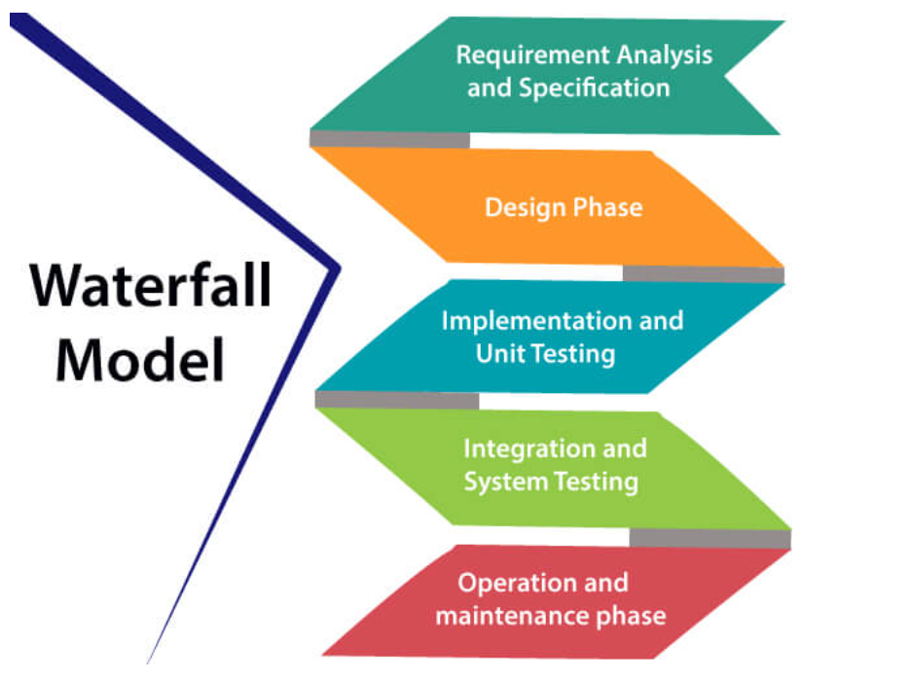

Advantages

* Structured and Easy to Manage: Each phase has specific deliverables and milestones, which simplifies management and progress tracking.
* Clear Documentation: Extensive documentation is created at each phase, which helps in maintaining project clarity and facilitates handovers.
* Predictable Timelines: The sequential nature of Waterfall allows for clear timelines and milestones.

Disadvantages

* Inflexible to Changes: Once a phase is completed, going back to make changes is challenging and costly.
* Late Testing: Issues may not be discovered until the testing phase, potentially leading to costly fixes.
* Not Ideal for Complex or Long-Term Projects: Complexity increases the risk of missing requirements that emerge later in the project.

Applicability

* Projects with Stable Requirements: Best for projects with well-defined and unchanging requirements, like certain manufacturing or infrastructure projects.
* Short-Term Projects: Suitable for short-term projects where requirements are clear from the start.
* Regulated Industries: Often used in industries that require thorough documentation and adherence to standards, such as construction or automotive engineering.

**2. Agile Model**

Overview

Agile development is iterative and incremental, focusing on customer collaboration, flexible responses to change, and frequent delivery of functional software. Popular Agile methodologies include Scrum, Kanban, and Extreme Programming (XP).

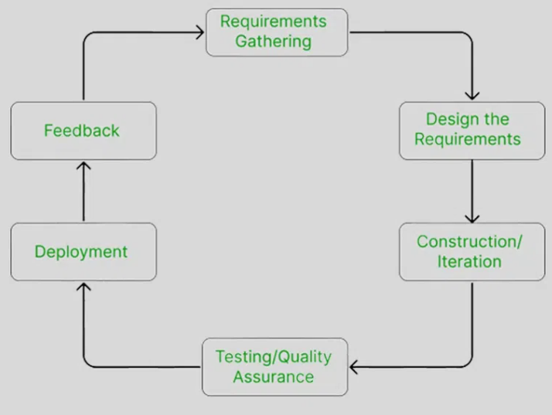

Advantages

* Highly Flexible: Can adapt to changing requirements throughout the development process.
* Frequent Delivery: Provides working software early and often, allowing for regular user feedback and course correction.
* Increased Customer Satisfaction: Continuous involvement of the customer ensures that the end product aligns with their expectations.

Disadvantages

* Resource Intensive: Requires significant involvement from the entire team and frequent interaction with stakeholders.
* Less Predictable: Estimating time and cost can be difficult due to the iterative nature.
* Requires Skilled Team: Teams need to be experienced in Agile practices for effective implementation.

Applicability

* Projects with Evolving Requirements: Ideal for projects where requirements are expected to change or are initially unclear, such as software development for new technology applications.
* Complex and Long-Term Projects: Suitable for complex projects where ongoing adjustment and iterative development are beneficial, such as in high-tech engineering or IT projects.
* Collaborative Environments: Best suited for teams and organizations that support open communication and collaboration.

**3. Spiral Model**

Overview

The Spiral model combines iterative development with systematic risk management. It involves repeated cycles through four main phases: planning, risk analysis, engineering, and evaluation.

Advantages

* Proactive Risk Management: Identifies and mitigates risks early and throughout the project.
* Customer Feedback: Regular evaluation and stakeholder feedback help refine the project iteratively.
* Flexibility: Each iteration allows for revisiting and refining previous stages, accommodating changes effectively.

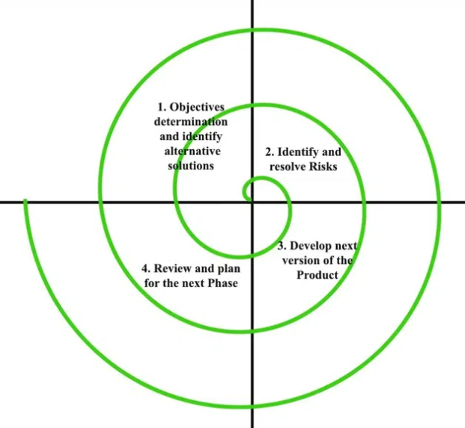

Disadvantages

* Complex Management: Requires rigorous management and planning, which can be resource-intensive.
* High Costs: The emphasis on risk management and iterative development can lead to higher costs.
* Special Expertise Needed: Requires expertise in both risk management and iterative development techniques.

Applicability

* High-Risk Projects: Ideal for projects where managing and mitigating risks is crucial, such as defense systems or aerospace engineering.
* Prototyping: Suitable for projects where early prototypes are needed to validate concepts and gather feedback.
* Large-Scale Projects: Best for large projects with complex requirements and high stakes.

**4. V-Model (Verification and Validation Model)**

Overview

The V-Model is an extension of the Waterfall model that emphasizes the verification and validation stages. Each development stage has a corresponding testing phase, forming a "V" shape when diagrammed.

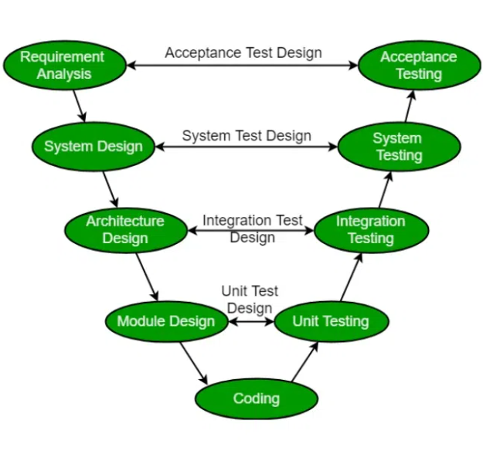

Advantages

* Clear Structure and Emphasis on Testing: Each development stage is directly linked to a testing phase, ensuring thorough verification and validation.
* Early Defect Detection: Rigorous testing at each stage helps identify defects early in the development cycle.
* Well-Defined Stages: Provides a structured approach with clear stages and deliverables.

Disadvantages

* Rigid and Inflexible: Like Waterfall, it’s challenging to accommodate changes once a phase is completed.
* High Documentation Requirements: Extensive documentation is necessary, which can be time-consuming.
* Not Suitable for Iterative Feedback: The sequential nature does not easily support iterative feedback and changes.

Applicability

* Safety-Critical Systems: Ideal for projects where safety and compliance are critical, such as medical device engineering or automotive systems.
* Stable Requirements: Best for projects with well-defined requirements that are unlikely to change.
* Highly Regulated Industries: Often used in industries requiring extensive documentation and validation, such as aerospace or pharmaceutical engineering.

